**I. ANG GINOO NAHIGUGMA KANIMO UG IYANG GUSTO NGA IKAW:**

**1. Kinahanglan aduna kinabuhi nga walay katapusan uban kaniya**. *Juan 3:16 si Jesus miingon, “Kay gihigugma pag-ayo sa Dios ang kalibotan ug tungod niini gihatag niya ang iyang bugtong Anak, aron ang tanan nga motuo kaniya dili mamatay, kondili makabaton hinuon sa kinabuhing dayon.”*

2. **Kinahanglan nga aduna kay madagayaon ug bulawanon nga kinabuhi.** *Juan 10:10 si Jesus nagsulti, “….. Mianhi ako aron makabaton kamo ug kinabuhing madagayaon.”*

Pero karaghana sa mga tao wala gayud makaexperiensia sa mabunga-hong kinabuhi ug wala usab makaseguro kun aduna ba silay kinabuhing walay katapusan tungod kay . . . .

**II. Ang tawo adunay problema sa SALA nga NAKAPA-HILAYO kaniya gikan sa Ginoo.**

**1. Ang tanan nakasala**. *Roma 3:23 nag-ingon, “Nakasala ang tanan ug nahilayo sa Dios.”*

**2. Ang bayad sa sala KAMATAYON**. *Roma 6:23, “Kay ang bayad sa sa pagpakasala mao ang kamatayon apan ang gasa sa Dios mao ang kinabuhing walay kataposan nga anaa kang Cristo Jesus nga atong Ginoo.”*

Ang Biblia nagsulti nga adunay duha ka klase sa kamatayon: Ang una: Pisikal. Ang ikaduha: Ispiritual o pagkahilayo sa Ginoo. *Pinadayag 21:8, “Apan ang mga talawan, ang mga mabudhion, ang mga malaw-ayon, ang mga mamumuno, ang mga makighilawason, ang mga salamangkiro, ang mga nagsimbag dios-dios,ug ang* ***TANANG BAKAKON*** *mahiagum gayod sa linaw nga kalayo ug asupre nga mao ang* ***Ikaduhang Kamatayon****.”*

Tungod kay ang sala nakapahimulag man kanato sa ginoo, nan unsa man ang solosyon niani nga problema?

**III. Si KRISTO JESUS *MAO* ra gyud ang dalan paingon sa LANGIT.**

**1. Siya RA GAYUD ang dalan.** Sa Juan 14:6 si Jesus miingon*, “Ako ang dalan, ug ang kamatuoran ug ang kinabuhi. Walay makaadto sa Amahan kundili pinaagi lamang kanako.”*

**2. Iya nang GIBAYRAN UG KOMPLETO nga bayad ang atong mga sala*.*** *Col 2;13, “Kaniadto patay kamo sa espiritu tungod sa inyong mga sala ug tungod kay dili man kamo mga Judeo,ug busa wala mahisakop sa balaod. Apan karon gibanhaw na kamo sa Dios uban ni Cristo! Gipasaylo na kita sa Dios sa tanan natong mga sala.”*

**IV. Ang PAGKABANHAW NI JESUS nagasiguro sa ato sa Kinabuhing Walay Katapusan.**

**1. Ang pagkabanhaw ni Jesu Kristo maoy naghatag kanato ug kaseguroan sa kinabuhing walay katapusan.**

Si Jesus nagpakamatay para sa atong mga sala, gilubong siya ug nabanhaw sa ika tulo ka adlaw.

1 Cor 15;3-4, “Gitudlo ko kaninyo ang akong nadawat nga mahinungdanon kaayo, ug kini mao nga si Cristo namatay alang sa atong mga sala,sumala sa nahisulat sa Kasulatan; gilubong siya ug sa ikatulo ka adlaw gibanhaw sumala sa nahisulat sa Kasulatan.”

**2. Ang pagkabanhaw ni Ginoong Jesus nagpamatuod nga siya gayud ang anak sa Ginoo.**

*Roma 1;3-4 “Mahitungod kini sa iyang Anak, ang atong Ginoong Jesu-Cristo; sa iyang pagkatawo, kaliwat siya ni David; sa iyang espirituhanong pagkabalaan gipadayag siya nga Anak sa Dios uban sa dakong gahom pinaagi sa iyang pagkabanhaw.”*

**3. Si Jesus nagsaad ug kinabuhi nga walay katapusan.**

*Si Jesus mismo nagingon sa Juan11: 25-26, “ Ug si Jesus miingon kaniya, ako ang pagkabanhaw ug ang kinabuhi. Ang motuo kanako, bisan tuod mamatay, mabuhi, ug an tanan nga buhi ug nagtuo kanako dili gayud mamatay. Mutuo ka ba niini?*

Ang pag-kabalo lang kun unsa ang gibuhat ni Jesu-Cristo dili paigo.

**V. Gikinahanglan nga atong ibutang ang ATONG PAGTUO DIHA NI JESU-CRISTO sa pagluwas kanato.**

**a. Ikaw naluwas tungod sa grasya sa Ginoo pinaagi sa pagtuo diha ni Jesu-Cristo.**

*Epeso 2:8-9, “ Kay pinaagi sa pagtuo naluwas kamo tungod sa grasya sa Dios. Busa walay makapasigarbo niini sanglit dili man bunga sa inyong mga paningkamot.”*

Ang pagkaluwas tungod sa pagtuo nagpasabot nga ATONG IBUTANG ANG ATONG PAGSALIG DIHA LAMANG NI CRISTO JESUS nga maoy makaluwas kanato. Ang maayong buhat dili mao ang paagi sa pagkaluwas kundili mao ang ebidensia o resulta sa imong pagkalinuwas.

**b. Ipadayag ang imong sinseridad sa imong pagtuo pinaagi sa pagpalayo sa kinabuhi nga makasal-anan.**

*“Ako nagsangyaw aron sila maghinulsol ug mobalik sa Ginoo ug ang proweba sa paghinulsol mao ang binuhatan. Ang tinud-anay nga nangayo ug pasaylo maningkamot sa pagbag-o sa iyang binuhatan.” Buhat 26:20*

Kabalo ang Dios nga dili kita perpekto, apan ang sinseridad sa atong pagsalig magalihok kanato saatong kinabuhi nga magpakita sa atong pagkamasalamaton sa Dios sa Iyang libre nga gasa sa langit.

Pwede nimo kining ampoon ang ang simple nga pag-ampo sa pagpadayag sa imong pagtuo diha ni Jesu-Cristo ug dawaton siya diha sa imong kasing-kasing isip imong Ginoo ug Manluluwas. Kausa ra nimo kini ampoon pero gikinahanglan nga adunay sensiredad kay kung mosulod ang Ginoo sa imong kinabuhgi, dili ka na gayud niya biyaan.

**PAG-AMPO**; ***Ginoong Jesu Cristo…*** ***Ako usa ka makasasala, Ako nag hinulsol ug Akong talikdan ang tanan kong sala. Ako nagtoo Jesus nga ikaw namatay para sa akong mga sala, nga Ikaw gilubong ug Ikaw nabanhaw gikan sa mga patay. Akong gi angkon ang imong saad nga ipasaylo Mo ang tanan kong sala, ug akong gidawat ang Imong gasa nga kinabuhing walay kataposan. Salamat sa Imong pagpalansang sa krus , salamat sa imong pag pasaylo sa akong mga sala, ug salamat gyud sa paghatag Mo kanako ug kinabuhing walay kataposan. Amen.***



**God’s Amazing Word, The Bible**. We believe the Bible is the Word of God. That’s why we teach it. It has authority. That's why our church leaders are focused on it. And, we believe in submitting or obeying God’s appointed leaders. God’s word is so powerful that when you share God’s word and the Holy Spirit, and you share it with the love of Jesus Christ, it has the power to transform lives. **Pet 1:20-21,** *“But know this first of all, that no prophecy of Scripture is a matter of one’s own interpretation, for no prophecy was ever made by an act of human will, but men moved by the Holy Spirit spoke from God.”*

**2 Tim 3:15-16,** *“and that from childhood you have known the sacred writings which are able to give you the wisdom that leads to salvation through faith which is in Christ Jesus. All Scripture is inspired by God and profitable for teaching, for reproof, for correction, for training in righteousness; so that the man of God may be adequate, equipped for every good work.”*

**AMAZING UNITY.** The Bible reads as if it were written by one author. It consists of 66 separate books; 40 different authors from different backgrounds (kings, fishermen, educated, and uneducated), cultures, and times. It was also written over a very long period of about 1600-2000 years, in 3 different continents: Asia, Africa and Europe; and in 3 languages: Hebrew, Greek and Aramaic. It is in complete agreement from Genesis to Revelation. It is in complete agreement about who God is, His nature, His character. It is in complete agreement about man – that he is a sinner and needs salvation. It’s in agreement about the way of salvation. It agrees on controversial topics like marriage and divorce, on the importance of family. It agrees on controversial issues dealing with homosexuality. From Genesis to Revelation – a complete unity, a complete whole – **66 Books, 40 authors, one complete unity, one author, GOD!**

**AMAZING FULFILLED PROPHECY.** No other book in the world has prophecy like the Bible. It has amazing fulfilled prophecies, telling events that are going to happen before they happen, which only God can do. Only the Bible has prophecy that is 100% accurate. From the book of **Isaiah 46:9-10**, God challenges us about what He can do: *"Remember the former things long past, For I am God, and there is no other; I am God, and there is no one like Me, Declaring the end from the beginning, And from ancient times things which have not been done, Saying, ‘My purpose will be established, And I will accomplish all My good pleasure’.”*

The Bible has over 300+ prophecies in the OT concerning the first coming of Jesus Christ. Why did God give so many? He wanted us to know exactly when Jesus Christ came, that we would know He is the one, the Messiah. And every single one of them was fulfilled in the Bible and in Christ. It was prophesied in the book of Isaiah, some 700 years before Christ, that He would come from the line of David (Is. 11:1; Matt 1:1-17). It predicted His birthplace, Bethlehem (Mic 5:2; Matt.2:1), and that his Birth would be followed by a Massacre (Jer. 31:15, Matt 2). It said, a herald would announce His coming (Is 40:3; Matt 3:3). It said He would be betrayed for 30 pieces of silver (Zech 11: 12-13) It said, He would be silent before His accusers (Is 53:7, Matt. 27:12). The Messiah would be pierced (Ps 22:16; Jn 19:33-34), telling us He would die through crucifixion. And then it said not a bone would be broken (Ps 34:20; Jn 19:32). God foretold every one of these events and every single one of them were fulfilled in the life of Christ.

A CCF Weekly Bulletin

**July 12, 2009 192nd Edition**

**CCF Center, Petrina Building, Casisang, Malaybalay City Cell No. 09169150404 email:** [**ccf_malaybalay@yahoo.com**](mailto:ccf_malaybalay@yahoo.com)

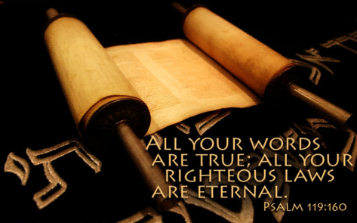



## Romans 13:1

**13:1 Let every person be subject to the governing authorities. For there is no authority except from God, and those that exist have been instituted by God. (**[**ESV**](http://www.esv.org)**)**

We not only have things concerning Jesus Christ. Jesus said in the book of **Matt. 24:2**, as He was out with his disciples, looking at Herod’s beautiful, magnificent temple: *"Do you not see all these things? Truly I say to you, not one stone here will be left upon another, which will not be torn down.”* Jesus words came true 100% in just a short time after that. In the year 70 A.D., the Roman general Titus besieged Jerusalem. He killed many of the Jews, and the Jews from that point on were scattered all over the world, just as the prophets foretold. That happened the second time in May 14, 1948 (the first time was after the Babylonian captivity). **Isaiah (11:11-12),** the Prophet foretold that day**: “***Then it will happen on that day that the Lord Will again recover the second time with His hand The remnant of His people, who will remain, And He will lift up a standard for the nations and assemble the banished ones of Israel, and will gather the dispersed of Judah from the four corners of the earth.*

**AMAZING CHANGED LIVES.** God’s word has the amazing power to change lives. **Heb 4:12,** *“For the word of God is living and active and sharper than any two-edged sword, and piercing as far as the division of soul and spirit, of both joints and marrow, and able to judge the thoughts and intentions of the heart.”* God’s word is powerful that it can pierce deep down into our hearts, and then bring conviction, and bring salvation.

Jesus Christ in **Matt 24:35** said,*“Heaven and earth will pass away but my word will never pass away.”*Read the Bible. Apply it! Obey it! The teachings of the Bible are derived from the authority of God. As Christians, we are to obey the teachings of the Bible.

**Heb 13:17** says, *Obey your leaders, and submit to them; for they keep watch over your souls, as those who will give an account. Let them do this with joy and not with grief, for this would be unprofitable for you.* Submission to God’s appointed leaders is a command. The underlying motivation to submit is to love. If you do not love God, you will not learn how to love others. If you don’t love others, you will find it so difficult to submit to the authority of God’s appointed leaders. **Rom 13:1a, “***Let every person be in subjection to the governing authorities.”* **1 Pet 2:18, /b>*Servants, be submissive to your masters with all respect, not only to those who are good and gentle, but also to those who are unreasonable.* Eph 5:22, “*Wives, be subject to your own husbands, as to the Lord.* The Bible says there is no option. Eph 6:1-3, “*Children, obey your parents in the Lord, for this is right. [2] Honor your father and mother (which is the first commandment with a promise), [3] that it may be well with you, and that you may live long on the earth.***

**Why do we need to submit to god’s appointed leaders? Because (1) *They are under the authority of Jesus Christ.*** Romans 13:1 says: *Let every person be in subjection to the governing authorities. For there is no authority except from God, and those which exist are established by God.* **(2)** ***They are our examples to follow*. 1 Cor 11:1, “***Be imitators of me, just as I also am of Christ.”* **(3) *They look after the welfare of believers*.** We submit because it is an act of faith. **John 14:21** says, *"He who has My commandments and keeps them, he it is who loves Me; and he who loves Me shall be loved by My Father, and I will love him, and will disclose Myself to him."* The living proof of loving God is keeping His commandments. The proof of loving God is submitting to His scriptures and a key application is submitting to God’s appointed leaders. Know the love of God in order to do that.

## 1 Peter 1:20-21

20 He was foreknown before the foundation of the world but was made manifest in the last times for the sake of you 21 who through him are believers in God, who raised him from the dead and gave him glory, so that your faith and hope are in God. ([ESV](http://www.esv.org))

## 2 Timothy 3:15-16

15 and how from childhood you have been acquainted with the sacred writings, which are able to make you wise for salvation through faith in Christ Jesus. 16 All Scripture is breathed out by God and profitable for teaching, for reproof, for correction, and for training in righteousness, ([ESV](http://www.esv.org))

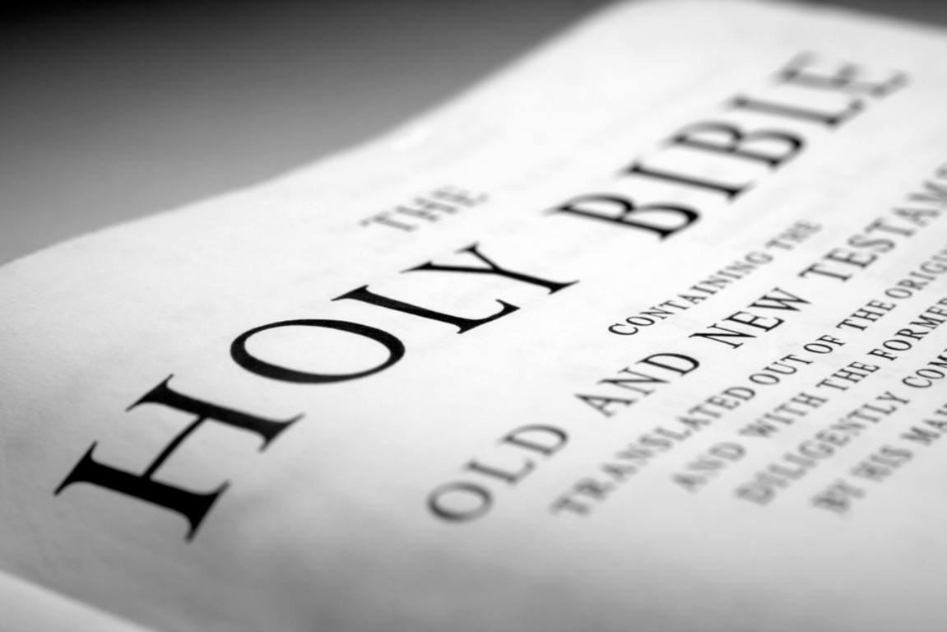

### CCF Vision Statement

Our vision is to see a movement of millions of committed followers of the Lord Jesus Christ meeting in small groups, transforming: Lives, Families, Communities and Nations for the Glory of God!

**CCF BRANCHES**

**CCF St. Francis Square**  
6/F St. Francis Square Bldg.  
Julia Vargas Ave., cor. Bank Drive  
Ortigas Center, Mandaluyong City  
Tel. No.: (+632) (02) 6353410 to 17  
Fax No.: (+63) (02) 6353418

**CCF Alabang**  
3/F CCF Bldg.  
Prime St., Madrigal Business Park  
Alabang, Muntinlupa City  
Tel. No.: (+63) (02) 7723035 to 39  
Fax: (+63) (02) 7723031

**CCF Binondo**  
10/F WorldTrade Exchange Bldg.  
215 Juan Luna St.  
Tel. No.: (+63) (02) 2441720  
Contact: Ptr. Albert Noel

**CCF Cagayan de Oro**  
#8 Agudo Road ,PJ Square, Limketkai Center  
Tel. no.: (+63) (88) 857-3000

**CCF Cavite**  
2/F Sun City Plaza  
Aguinaldo Hi-way,Anabu 2, Imus  
Tel. No.: (+63) 09178412340

**CCF Cebu**  
Lower G/F Machay Bldg.  
30 Gorordo Ave.  
Tel. No.: (+63) (32) 231-8303

[**CCF Davao**](http://www.ccf.org.ph/about-us/ccf-davao/)  
JP Laurel Ave., Bajada  
Tel. Nos.: (+63) (82) 2286220  
(+63) 09175777794

**CCF Eastwood**  
Eastwood Cinema  
Tel. No.: +639189288000

**CCF Isabela**  
San Mateo Road, Alicia  
Tel. No.: (+63) (78) 6627071

**CCF Malaybalay**  
G/F Petrina Bldg.  
Casisang, Malaybalay City, Bukidnon  
Tel. No.: (+63) (916) 9150404

**CCF Malolos**  
2/F Balaga Bldg.  
Dakila, McArthur Hi-way  
Tel. No.: (+63) (44) 6625780

**CCF Marikina**  
3/F Audiophile Bldg.  
J. Abad Santos St. cor. Diego Silang St.  
Tel. No. (+63) (02) 4903623

**CCF Marilao**  
El Bolakeño Village  
McArthur Highway, Saog  
Tel. No.: (+63) 0917-541-3821

**CCF Pampanga**  
2/F Metrobank Bldg.  
Sindalan, San Fernando City  
Tel. No.: (+63) (45) 6364190

**CCF Pasig**  
Cinema 1, Ever Gotesco  
Ortigas Extension  
Tel. No.: (+63) (02) 6563722

**CCF Singapore**  
The Cathay Cineplexes  
Level 6 Hall 2, 2 Handy Road  
Singapore 229233  
Contact: Matthew dela Serna  
Office Tel. No.: (+65) 6823 6270  
Fax No.: (+65) 6829 1270

**CCF Taytay**  
Peaksun Building  
Manila East Road  
Tel. No.: (+63) (02) 6609322

**CCF ALANIB**  
MKADC Compound, Alanib, Lantapan

… And counting!

|  |  |
| --- | --- |
| **Branch** | **Time** |
| St. Francis Square 5th Floor Auditorium | 8:00-9:00 A.M. |
| 10:00-11:30 A.M. |
| 12:00-1:30 P.M. |
| 3:00-5:00 P.M. (Filipino) |
| 6:00-7:30 P.M. |
| [Alabang](http://www.ccf-alabang.org) | 8:00-9:30 A.M. |
| 10:00-11:30 A.M. |
| 12:00-1:30 P.M. |
| 3:30-5:00 P.M. (Filipino) |
| [Cagayan de Oro](http://www.ccf.org.ph/about-us/branches-church-planting#cdo) | 10:00 A.M. - 12:00 NN. |
| 4:30-6:00 P.M. |
| [Cavite](http://www.ccf.org.ph/about-us/branches-church-planting#cavite) | 8:00-9:30 A.M. |
| 10:00-11:30 A.M. |
| [Cebu](http://www.ccf.org.ph/about-us/branches-church-planting/ccf-cebu) | 10:00 P.M. - 12:00 NN (Ayala Cinema 2) |
| [Davao](http://www.ccf.org.ph/about-us/branches-church-planting/ccf-davao) | 10:00-11:30 A.M. |

|  |  |
| --- | --- |
| **Branch** | **Time** |
| [Isabela](http://www.ccf.org.ph/about-us/branches-church-planting#isabela) | 9:00-11:00 A.M. |
| [Malaybalay](http://www.ccf.org.ph/about-us/branches-church-planting#malaybalay)/ Alanib | 10:00 A.M. -12:00 NN |
| [Malolos](http://www.ccf.org.ph/about-us/branches-church-planting#malolos) | 7:30-9:30 A.M. |
| 9:30-11:30 A.M. |
| [Marikina](http://www.ccfmarikina.com) | 9:30-11:30 A.M. |
| [Marilao](http://www.ccf.org.ph/about-us/branches-church-planting#marilao) | 8:00-10:00 A.M. |
| [Pampanga](http://www.ccf.org.ph/about-us/branches-church-planting#pampanga) | 10:00-12:00 A.M. |
| [Pasig](http://www.ccf.org.ph/about-us/branches-church-planting#pasig) | 8:00-10:00 A.M. |
| 3:30-5:30 P.M. |
| [Singapore](http://www.ccf-singapore.org) | 10:00 A.M. - 12:00 NN |
| [Taytay](http://www.ccf.org.ph/about-us/branches-church-planting/ccf-taytay) | 8:30-10:00 A.M. |
| 10:30 A.M. - 12:00 NN |

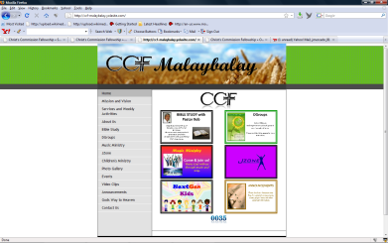

[www.ccf-malaybalay.yolasite.com](http://www.ccf-malaybalay.yolasite.com)

Kindly make your comments and suggestions

Making Christ Committed Follower who will make Christ Committed Follower who will make Christ Committed Follower…