### I. GOD LOVES YOU and desires that you:

**1. Have eternal life with Him.**

“For God so loved the world, that He gave His only begotten Son, that whoever believes in Him should not perish, but have eternal life.” John 3:16

**2. Have an abundant and meaningful life.**

“Jesus said, ‘… I came that they might have life, and have it abundantly.’” John 10:10

But most people aren’t experiencing a meaningful life and aren’t sure that they have eternal life because…

### II. Man has a SIN problem that SEPARATES him from GOD.

**1. Everyone has sinned. “**… For all have sinned and fall short of the glory of God….” Romans 3:23 (also ESV, NIV)

**2. The penalty for sin is DEATH. “**For the wages of sin is death….” Romans 6:23 (also ESV, NIV)

The Bible talks about two kinds of death. The first death is physical. The second death is spiritual or eternal separation from God.

“But for the cowardly and unbelieving and abominable and murderers and immoral persons and sorcerers and idolaters and **all liars**, their part will be in the lake that burns with fire and brimstone, which is the **Second Death**.” Revelation 21:8

Because sin separates man from God, what is the solution to his problem?

### III. JESUS CHRIST is God’s ONLY way to heaven.

**1. He is the ONLY way. “**Jesus said… ‘I am the way, and the truth, and the life; no one comes to the Father, but through Me.’” John 14:6

**2. He COMPLETELY PAID the penalty of your sins.**

“For Christ also died for sins once for all, the just for the unjust, in order that He might bring us to God….” 1 Peter 3:18

**3. His resurrection proves that He is the Son of God, the Messiah, the only Savior.**

“… Concerning His Son, who was born of a descendant of David according to the flesh, who was declared the Son of God with power by the resurrection from the dead, according to the Spirit of holiness, Jesus Christ our Lord….” Romans 1:3-4

**4. He promises Eternal Life.**

“Jesus said … ‘I am the resurrection and the life; he who believes in Me shall live even if he dies, and everyone who lives and believes in Me shall never die….’” John 11:25-26

However, merely knowing what Jesus Christ has done for us is not enough.

### IV. We must place our FAITH IN JESUS CHRIST to save us.

**1. You are saved by God’s grace through faith in Jesus Christ.**

“For it is by grace you have been saved, through faith - and this is not from yourselves, it is the GIFT OF GOD - not by works, so that no one can boast.” Ephesians 2:8-9 (NIV)

To be saved by faith means to TRUST IN JESUS CHRIST ALONE to save you. Good works are not the means to salvation; rather, they are the byproducts or evidence of your salvation.

**2. Show your faith in Jesus Christ by accepting His gift of eternal life.**

“[Jesus says,] ‘Behold, I stand at the door and knock; if anyone hears My voice and opens the door, I will come in to him and will dine with him, and he with Me.’” Revelation 3:20

Jesus says that He will come into your heart if you invite Him in. That is His promise to you, and He will always keep His promise!

**3. Prove the sincerity of your faith by turning away from a life of sin.**

“I preached that they should repent and turn to God and prove their repentance by their deeds. A person who genuinely asks for forgiveness will seek to change his ways.” Acts 26:20 (NIV)

**God knows we are not perfect, but the sincerity of our faith will move us to live lives that show our gratitude to God for His free gift of heaven.**

**You can pray this simple prayer to express your faith in Jesus Christ and to receive Him into your heart as your Lord and Savior. You only have to pray this prayer once, but with sincerity, because when He enters your life, he will never leave you.**

**PRAYER:** Lord Jesus, I need You. I confess that I am a sinner. I believe that you died on the cross to pay for all my sins. With your help, I will turn away from all my sins. Please come into my life and be my Lord and Savior. I accept your free gift of eternal life. Make me the kind of person you want me to be. Thank you for coming into my life and giving me eternal life. Amen.



Every organization has a Mission and Vision Statement. At CCF, ours is God-given. Our Mission is what Jesus commanded: *"Go and make disciples of all nations"* (Matthew 28:19). In everything we do, wherever we go, we are to bring people to Christ through evangelization. Then, we are to train, equip, and help them grow spiritually, so that in turn, they can disciple others. When we accomplish this Mission, lives are transformed through the power of God.

This, therefore, is our Vision: we want to see millions of people around the world become Christ's disciples. To achieve this, we are to act according to our Core Values.

Like our Mission and Vision, our Core Values as CCFers and as Christians are biblical. These are values that God wants us to practice.

Among our Core Values, the foremost is **LOVE** — love of God, family, and neighbor. The apostle Peter tells us, *"Above all,* ***keep fervent in your love*** *for one another..."* (1 Peter 4:8). When asked by Jewish rabbis for the greatest commandment, Jesus himself said, *"You shall* ***love the Lord your God with all your heart, and with all your soul, and with all your mind, and with all your strength****... You shall love your neighbor as yourself. There is no other commandment greater than these:* (Mark 12:30-31).

This dialogue between Jesus and the rabbis happened as religious leaders of the time had complicated religion by expanding the Ten Commandments into 613 do's and don'ts. For example, because working on the Sabbath day was prohibited, there was a list of activities that were considered "work:" walking too many steps, lighting a fire, carrying too many eggs, etc. Even today in the Holy Land, Orthodox Jews are so legalistic that on Saturdays (the Jewish Sabbath), they use a "Sabbath Elevator." It stops at every floor of a building so that no one has to press a button — pressing a button qualifies as "work."

Like these Jews, we are often busy with other things and forget the most basic, most important Christian value of love.

Why is love so important? The evidence of our spiritual maturity is our ability to love. John 13:35 tells us, *"By this,* ***all men will know that your are My disciples, if you have love for one another.****"* 1 Corinthians also tells us, *"If I speak with the tongues of men and of angels, but do not have love, I have become a noisy gong or a clanging cymbal. And if I have the gift of prophecy, and know all mysteries and all knowledge; and if I have all faith, so as to remove mountains, but do not have love, I am nothing. And if I give all my possessions to feed the poor, and if I deliver my body to be burned, but do not have love, it profits me nothing."*

A CCF Weekly Bulletin

**June 28, 2009 190th Edition**

**CCF Center, Petrina Building, Casisang, Malaybalay City Cell No. 09169150404 email:** [**ccf_malaybalay@yahoo.com**](mailto:ccf_malaybalay@yahoo.com)





## 1 Peter 4:8-10

**8 Above all, keep loving one another earnestly, since love covers a multitude of sins. 9 Show hospitality to one another without grumbling. 10 As each has received a gift, use it to serve one another, as good stewards of God's varied grace: (**[**ESV**](http://www.esv.org)**)**

We can know every word of the bible, give away our money, and be busy with ministry and church activities, but if we do not love God and one another, we are a uselessly clanging cymbal; all show and no substance. Christianity is not external; it is from the heart. The Bible tells us, *"... Let us love another, for love is from God... the one who does not love his brother whom he has seen, cannot love God whom he has not seen"* (1 John 4:7,19-20).

If we love God, we will do everything to be holy as He is holy, we will not disobey His commandments, and we will love other people as He does.

how do we love other people? We love others as Jesus loved us — unconditionally. Despite our sins and imperfections, Jesus sacrificed himself so we could be saved. It is difficult to love other people, especially imperfect people. True love, however, is a commitment to imperfect people, to seek their highest good, which often requires sacrifice.

1 Peter 4:8 tells us to ***"keep loving other people fervently because love covers a multitude of sins."*** To love biblically is to love fervently, which requires extreme effort, a full stretching of the muscles. To love imperfect people fervently is to **ACCEPT** them despite their imperfections, **FORGIVE** their transgressions, and **AFFIRM** and appreciate them. We ourselves are not perfect.

We may be very different from others, but we must accept them, even when they unintentionally disappoint us, and more so when they purposely hurt us. Matthew 5:44 says, *"But I say to you, love your enemies, and pray for those who persecute you."* We must be willing to forgive their sins as Christ has forgiven us, yet we must not gossip about them nor condone their wrongdoings.

To love fervently, we must not only show acceptance and forgiveness; we must also affirm people by making them feel precious and worthy. To affirm people is to encourage them, bless them, and build them up despite their failures.

1 Peter 4:9-10 tells us, *"****Be hospitable to one another without complaint.*** *As each one has received a special gift, employ it in serving one another as good stewards of the manifold grace of God."* Hospitality is treating people as we treat our guests, serving them well, and making them feel welcome, important, and trusted.

Loving people is the most effective way to evangelize them. Many people do not like Christianity because of the way they were treated by Christians. Love brings people to Jesus; it is our mission to love them. When our family members and neighbors see us and the way we live our lives, are they encouraged to follow Jesus? If not, then it is time for us to receive and experience the love of God and learn to love other people fervently. It is time for us to focus on God's love and to practice loving our fellow imperfect people.

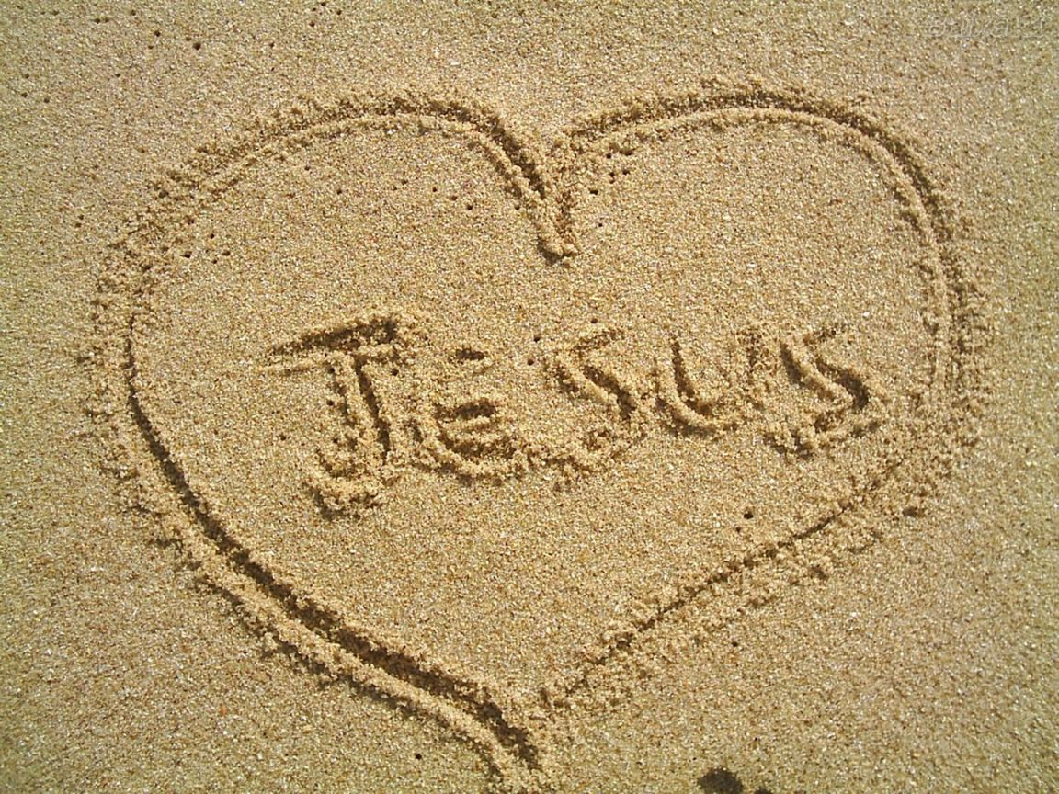

### CCF Vision Statement

Our vision is to see a movement of millions of committed followers of the Lord Jesus Christ meeting in small groups, transforming: Lives, Families, Communities and Nations for the Glory of God!

**CCF BRANCHES**

**CCF St. Francis Square**  
6/F St. Francis Square Bldg.  
Julia Vargas Ave., cor. Bank Drive  
Ortigas Center, Mandaluyong City  
Tel. No.: (+632) (02) 6353410 to 17  
Fax No.: (+63) (02) 6353418

**CCF Alabang**  
3/F CCF Bldg.  
Prime St., Madrigal Business Park  
Alabang, Muntinlupa City  
Tel. No.: (+63) (02) 7723035 to 39  
Fax: (+63) (02) 7723031

**CCF Binondo**  
10/F WorldTrade Exchange Bldg.  
215 Juan Luna St.  
Tel. No.: (+63) (02) 2441720  
Contact: Ptr. Albert Noel

**CCF Cagayan de Oro**  
#8 Agudo Road ,PJ Square, Limketkai Center  
Tel. no.: (+63) (88) 857-3000

**CCF Cavite**  
2/F Sun City Plaza  
Aguinaldo Hi-way,Anabu 2, Imus  
Tel. No.: (+63) 09178412340

**CCF Cebu**  
Lower G/F Machay Bldg.  
30 Gorordo Ave.  
Tel. No.: (+63) (32) 231-8303

[**CCF Davao**](http://www.ccf.org.ph/about-us/ccf-davao/)  
JP Laurel Ave., Bajada  
Tel. Nos.: (+63) (82) 2286220  
(+63) 09175777794

**CCF Eastwood**  
Eastwood Cinema  
Tel. No.: +639189288000

**CCF Isabela**  
San Mateo Road, Alicia  
Tel. No.: (+63) (78) 6627071

**CCF Malaybalay**  
G/F Petrina Bldg.  
Casisang, Malaybalay City, Bukidnon  
Tel. No.: (+63) (916) 9150404

**CCF Malolos**  
2/F Balaga Bldg.  
Dakila, McArthur Hi-way  
Tel. No.: (+63) (44) 6625780

**CCF Marikina**  
3/F Audiophile Bldg.  
J. Abad Santos St. cor. Diego Silang St.  
Tel. No. (+63) (02) 4903623

**CCF Marilao**  
El Bolakeño Village  
McArthur Highway, Saog  
Tel. No.: (+63) 0917-541-3821

**CCF Pampanga**  
2/F Metrobank Bldg.  
Sindalan, San Fernando City  
Tel. No.: (+63) (45) 6364190

**CCF Pasig**  
Cinema 1, Ever Gotesco  
Ortigas Extension  
Tel. No.: (+63) (02) 6563722

**CCF Singapore**  
The Cathay Cineplexes  
Level 6 Hall 2, 2 Handy Road  
Singapore 229233  
Contact: Matthew dela Serna  
Office Tel. No.: (+65) 6823 6270  
Fax No.: (+65) 6829 1270

**CCF Taytay**  
Peaksun Building  
Manila East Road  
Tel. No.: (+63) (02) 6609322

**CCF ALANIB**  
MKADC Compound, Alanib, Lantapan

… And counting!

|  |  |
| --- | --- |
| **Branch** | **Time** |
| St. Francis Square 5th Floor Auditorium | 8:00-9:00 A.M. |
| 10:00-11:30 A.M. |
| 12:00-1:30 P.M. |
| 3:00-5:00 P.M. (Filipino) |
| 6:00-7:30 P.M. |
| [Alabang](http://www.ccf-alabang.org) | 8:00-9:30 A.M. |
| 10:00-11:30 A.M. |
| 12:00-1:30 P.M. |
| 3:30-5:00 P.M. (Filipino) |
| [Cagayan de Oro](http://www.ccf.org.ph/about-us/branches-church-planting#cdo) | 10:00 A.M. - 12:00 NN. |
| 4:30-6:00 P.M. |
| [Cavite](http://www.ccf.org.ph/about-us/branches-church-planting#cavite) | 8:00-9:30 A.M. |
| 10:00-11:30 A.M. |
| [Cebu](http://www.ccf.org.ph/about-us/branches-church-planting/ccf-cebu) | 10:00 P.M. - 12:00 NN (Ayala Cinema 2) |
| [Davao](http://www.ccf.org.ph/about-us/branches-church-planting/ccf-davao) | 10:00-11:30 A.M. |

|  |  |
| --- | --- |
| **Branch** | **Time** |
| [Isabela](http://www.ccf.org.ph/about-us/branches-church-planting#isabela) | 9:00-11:00 A.M. |
| [Malaybalay](http://www.ccf.org.ph/about-us/branches-church-planting#malaybalay)/ Alanib | 10:00 A.M. -12:00 NN |
| [Malolos](http://www.ccf.org.ph/about-us/branches-church-planting#malolos) | 7:30-9:30 A.M. |
| 9:30-11:30 A.M. |
| [Marikina](http://www.ccfmarikina.com) | 9:30-11:30 A.M. |
| [Marilao](http://www.ccf.org.ph/about-us/branches-church-planting#marilao) | 8:00-10:00 A.M. |
| [Pampanga](http://www.ccf.org.ph/about-us/branches-church-planting#pampanga) | 10:00-12:00 A.M. |
| [Pasig](http://www.ccf.org.ph/about-us/branches-church-planting#pasig) | 8:00-10:00 A.M. |
| 3:30-5:30 P.M. |
| [Singapore](http://www.ccf-singapore.org) | 10:00 A.M. - 12:00 NN |
| [Taytay](http://www.ccf.org.ph/about-us/branches-church-planting/ccf-taytay) | 8:30-10:00 A.M. |
| 10:30 A.M. - 12:00 NN |

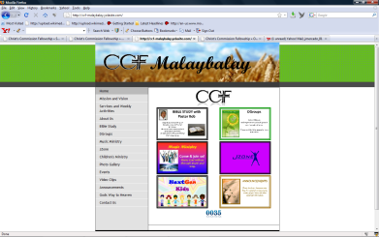

[www.ccf-malaybalay.yolasite.com](http://www.ccf-malaybalay.yolasite.com)

Kindly make your comments and suggestions

Making Christ Committed Follower who will make Christ Committed Follower who will make Christ Committed Follower…